CST 229 – Lecture 7
Wilsonville, Fall 2017

Ch 19: TM

Turing Machines
Invented by Alan Turing in 1936

He was looking for a formal, mathematical language for describing algorithms, so he could perform calculations to show whether problems were solvable algorithmically

The Church-Turing Thesis demonstrates that all digital computers are equivalent
They can each solve exactly the same set of problems
They are all equivalent to the theoretical Turing Machine

Remember that languages and machines have a special relationship…
Certain types of machines can accept certain types of languages
Language used to describe a machine’s function determines it’s capabilities

Any machine/language equivalent to a Turing Machine is called “Turing Complete”

Turing machines are defined by…
- Alphabet Σ of input letters
- Tape, infinite to the right, divided into cells containing characters or blank Δ
- Tape Head that can read/write and move left/right on the tape
- Alphabet Γ of letters that can be printed on the tape
- Finite set of states, one of which is indicated as the Start state, and one or more Halt states
- “Program” of rules that describe how to transition between states, when to write letters to the tape and which direction to move the tape.

Rules are typically coded as “triplets”, and diagramed on transitions between states
Triplet: (letter read, letter to write, direction to move tape)
Example: (a, A, Right)

The machine can crash if the tape is moved Left from the starting position, or if a transition cannot be found

Turing Machines are deterministic by definition

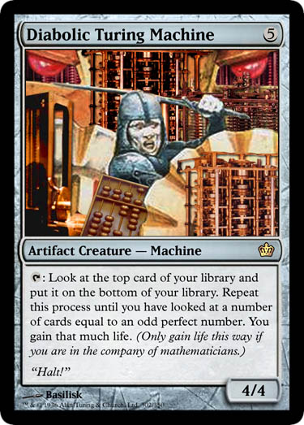
Two different idealized Turning Machines:

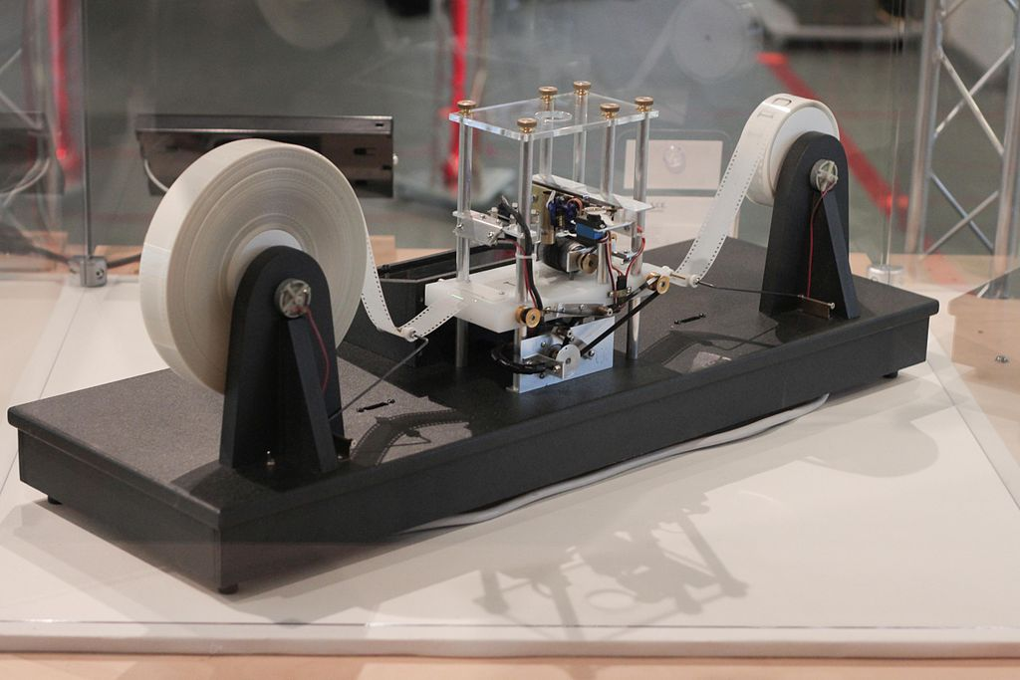
https://simple.wikipedia.org/wiki/Turing_machine
https://goodgamery.com/2010/01/diabolic-turing-machine/

Real Example Machine…
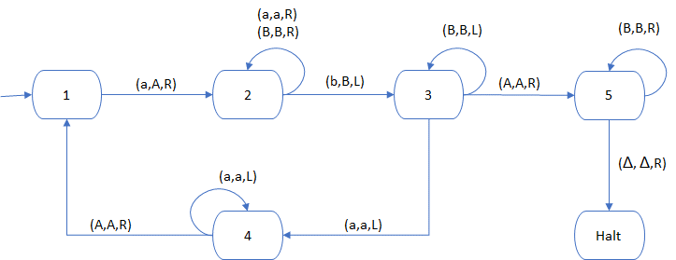
In table form, it looks like…

 | Current State | Input Letter | Write Letter | Direction | Next State
T1 | 1 | a | A | Right | 2
T2 | 2 | a | a | Right | 2
T3 | 2 | B | B | Right | 2
T4 | 2 | b | B | Left | 3
T5 | 3 | B | B | Left | 3
T6 | 3 | a | a | Left | 4
T7 | 3 | A | A | Right | 5
T8 | 4 | a | a | Left | 4
T9 | 4 | A | A | Right | 1
T10 | 5 | B | B | Right | 5
T11 | 5 | Δ | Δ | Right | Halt

What’s it doing?
Which language does this accept?
Try the string “aaabbb”…
- Start with string on the tape and R/W Head on the first letter
- Start in the initial state, 1
- Given current state…
  - Read from the head, ‘a’
  - Lookup the appropriate transition in the table, T1
  - Write letter for T1, ‘A’
  - Move head indicated direction, Right
  - Transition to next state, 2
- Rinse and repeat, until Halt or no transition found

Input Tape  (current position is bold) | Current State | Input Letter | Transition | Write Letter | Direction | Next State
aaabbbΔ | 1 | a | T1 | A | Right | 2
AaabbbΔ | 2 | a | T2 | a | Right | 2
AaabbbΔ | 2 | a | T2 | a | Right | 2
AaabbbΔ | 2 | b | T4 | B | Left | 3
AaaBbbΔ | 3 | a | T6 | a | Left | 4
AaaBbbΔ | 4 | a | T8 | a | Left | 4
AaaBbbΔ | 4 | A | T9 | A | Right | 1
AaaBbbΔ | 1 | a | T1 | A | Right | 2
AAaBbbΔ | 2 | a | T2 | a | Right | 2
AAaBbbΔ | 2 | B | T3 | B | Right | 2
AAaBbbΔ | 2 | b | T4 | B | Left | 3
AAaBBbΔ | 3 | B | T5 | B | Left | 3
AAaBBbΔ | 3 | a | T6 | a | Left | 4
AAaBBbΔ | 4 | A | T9 | A | Right | 1
AAaBBbΔ | 1 | a | T1 | A | Right | 2
AAABBbΔ | 2 | B | T3 | B | Right | 2
AAABBbΔ | 2 | B | T3 | B | Right | 2
AAABBbΔ | 2 | b | T4 | B | Left | 3
AAABBBΔ | 3 | B | T5 | B | Left | 3
AAABBBΔ | 3 | B | T5 | B | Left | 3
AAABBBΔ | 3 | A | T7 | A | Right | 5
AAABBBΔ | 5 | B | T10 | B | Right | 5
AAABBBΔ | 5 | B | T10 | B | Right | 5
AAABBBΔ | 5 | B | T10 | B | Right | 5
AAABBBΔ | 5 | Δ | T11 | Δ | Right | Halt

This TM accepts the laguage L = {a^{n}b^{n}, where n = 0, 1, 2…}
How about this one…
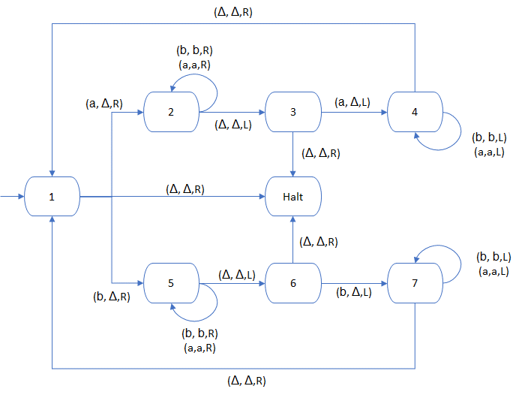

This accepts Palindromes!
In class, let’s build the state table…
 | Current State | Input Letter | Write Letter | Direction | Next State
T1 | 1 | a | Δ | R | 2
T2 | 1 | Δ | Δ | R | Halt
T3 | 1 | b | Δ | R | 5
T4 | 2 | a | a | R | 2
T5 | 2 | b | b | R | 2
T6 | 2 | Δ | Δ | L | 3
T7 | 3 | Δ | Δ | R | Halt
T8 | 3 | a | Δ | L | 4
T9 | 4 | b | b | L | 4
T10 | 4 | a | a | L | 4
T11 | 4 | Δ | Δ | R | 1
T12 | 5 | b | b | R | 5
T13 | 5 | a | a | R | 5
T14 | 5 | Δ | Δ | L | 6
T15 | 6 | Δ | Δ | R | Halt
T16 | 6 | b | Δ | L | 7
T17 | 7 | b | b | L | 7
T18 | 7 | a | a | L | 7
T19 | 7 | Δ | Δ | R | 1

…and try the string “aabaa”…

Input Tape  (current position is bold) | Current State | Input Letter | Transition | Write Letter | Direction | Next State
aabaaΔ | 1 | a | T1 | Δ | R | 2
ΔabaaΔ | 2 | a | T4 | a | R | 2
ΔabaaΔ | 2 | b | T5 | b | R | 2
ΔabaaΔ | 2 | a | T4 | a | R | 2
ΔabaaΔ | 2 | a | T4 | a | R | 2
ΔabaaΔ | 2 | Δ | T6 | Δ | L | 3
ΔabaaΔ | 3 | a | T8 | Δ | L | 4
ΔabaΔΔ | 4 | a | T10 | a | L | 4
ΔabaΔΔ | 4 | b | T9 | b | L | 4
ΔabaΔΔ | 4 | a | T10 | a | L | 4
ΔabaΔΔ | 4 | Δ | T11 | Δ | R | 1
ΔabaΔΔ | 1 | a | T1 | Δ | R | 2
ΔΔbaΔΔ | 2 | b | T5 | b | R | 2
ΔΔbaΔΔ | 2 | a | T4 | a | R | 2
ΔΔbaΔΔ | 2 | Δ | T6 | Δ | L | 3
ΔΔbaΔΔ | 3 | a | T8 | Δ | L | 4
ΔΔbΔΔΔ | 4 | b | T9 | b | L | 4
ΔΔbΔΔΔ | 4 | Δ | T11 | Δ | R | 1
ΔΔbΔΔΔ | 1 | b | T3 | Δ | R | 5
ΔΔΔΔΔΔ | 5 | Δ | T14 | Δ | L | 6
ΔΔΔΔΔΔ | 6 | Δ | T15 | Δ | R | Halt

Regular Languages and Turing Machines…

Theorem 46 (Pg. 445)
Every regular language has a TM that accepts exactly it.

We can simply construct a TM from the DFA for an RE
Just keep moving the tape to the right and always write the same letter just read
Add a Halt state when we run out of letters and we’re in a DFA accepting state

Example RE for for all strings that end in ‘a’: (a|b)*a

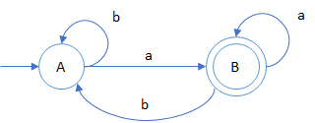
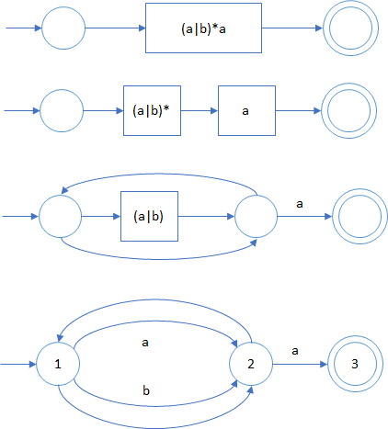

DFA State | a | b | Accept
A = {1,2} | {2,3,1} = B | {2,1} = A
B = {1,2,3} | {2,3,1} = B | {2,1} = A | Yes

So, what does that look like as a TM?

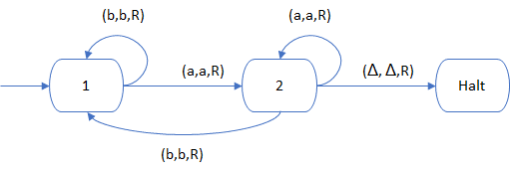
On the other end, how about Non-CF Languages?
For example… L = {a^{n}b^{n}a^{n} for n=0, 1, 2, 3…}

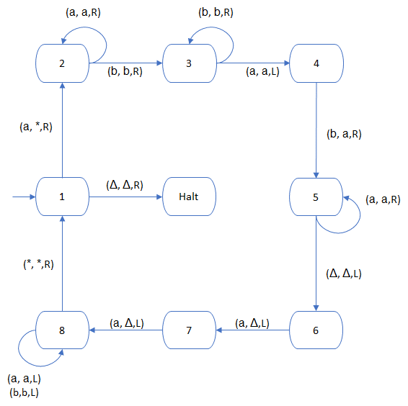

How does this work? Trace it through for the string “aabbaa”.
Generaly, it…
Replaces the first ‘a’ in the string with a ‘*’
Finds and deletes the last ‘b’ and the last ‘a’
Returns to the beginning and repeats
Until it finds only ‘*’ on the tape and then halts

Why does this work, when a PDA couldn’t do it?

